# PROBLEMA 1

## Black-Box

D1

D2

D3

S1

S2

S3

Decodificador que recibe un numero de 3 bits y genera su salida correspondiente en código Gray

## Correlación

|  |  |  |  |  |  |  |
| --- | --- | --- | --- | --- | --- | --- |
| J | S3 | S2 | S1 | D3 | D2 | D1 |
| 0 | 0 | 0 | 0 | 0 | 0 | 0 |
| 1 | 0 | 0 | 1 | 0 | 0 | 1 |
| 2 | 0 | 1 | 0 | 0 | 1 | 1 |
| 3 | 0 | 1 | 1 | 0 | 1 | 0 |
| 4 | 1 | 0 | 0 | 1 | 1 | 0 |
| 5 | 1 | 0 | 1 | 1 | 1 | 1 |
| 6 | 1 | 1 | 0 | 1 | 0 | 1 |
| 7 | 1 | 1 | 1 | 1 | 0 | 0 |

## Diagrama Digital

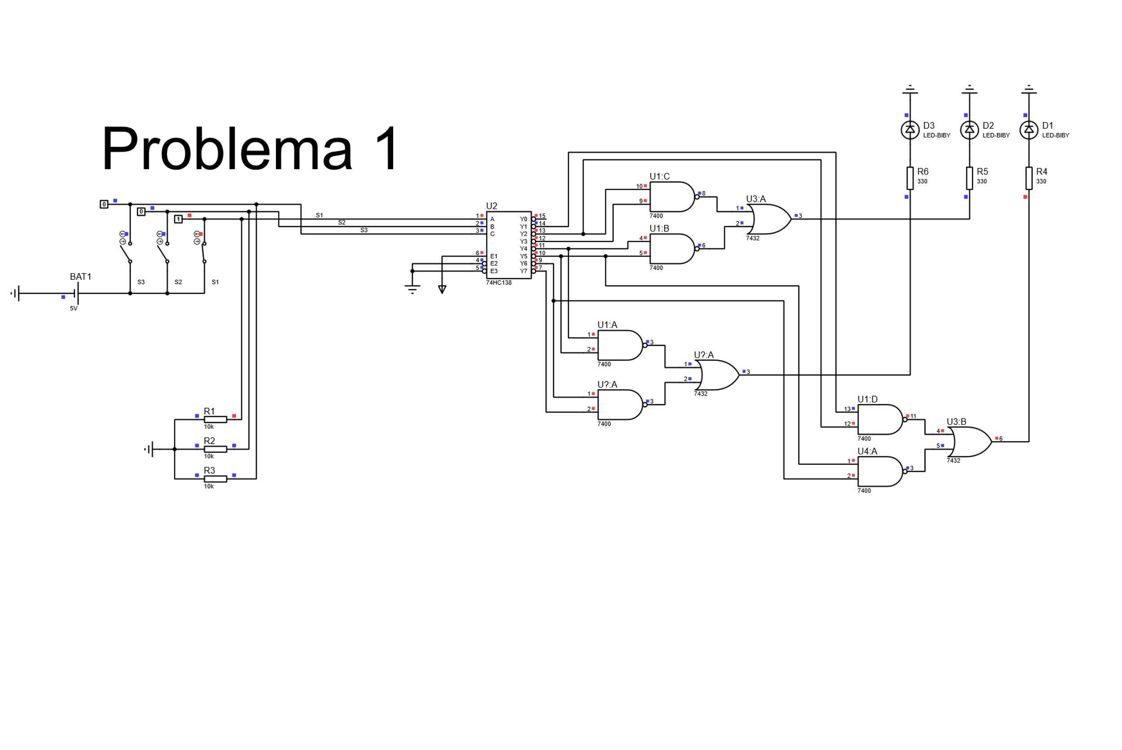

# PROBLEMA 2

## Black-Box

U

D

S1

S2

S3

Numero decimal de 3 bits multiplicado por 6 mostrándose en dos displays

## Correlación

|  |  |  |  |  |  |  |  |  |  |  |  |  |  |
| --- | --- | --- | --- | --- | --- | --- | --- | --- | --- | --- | --- | --- | --- |
|  | BCD | | | Decenas (D) | | | | Unidades (U) | | | |  | BCD*6 |
| J | **S3** | **S2** | **S1** | **D4** | **D3** | **D2** | **D1** | **U4** | **U3** | **U2** | **U1** |  |
| 0 | 0 | 0 | 0 | 0 | 0 | 0 | 0 | 0 | 0 | 0 | 0 |  | 0 |
| 1 | 0 | 0 | 1 | 0 | 0 | 0 | 0 | 0 | 1 | 1 | 0 |  | 6 |
| 2 | 0 | 1 | 0 | 0 | 0 | 0 | 1 | 1 | 0 | 1 | 0 |  | 12 |
| 3 | 0 | 1 | 1 | 0 | 0 | 0 | 1 | 0 | 0 | 0 | 0 |  | 18 |
| 4 | 1 | 0 | 0 | 0 | 0 | 1 | 0 | 0 | 1 | 0 | 0 |  | 24 |
| 5 | 1 | 0 | 1 | 0 | 0 | 1 | 1 | 0 | 0 | 0 | 0 |  | 30 |
| 6 | 1 | 1 | 0 | 0 | 0 | 1 | 1 | 0 | 1 | 1 | 0 |  | 36 |
| 7 | 1 | 1 | 1 | 0 | 1 | 0 | 0 | 0 | 0 | 1 | 0 |  | 42 |

## Diagrama Digital

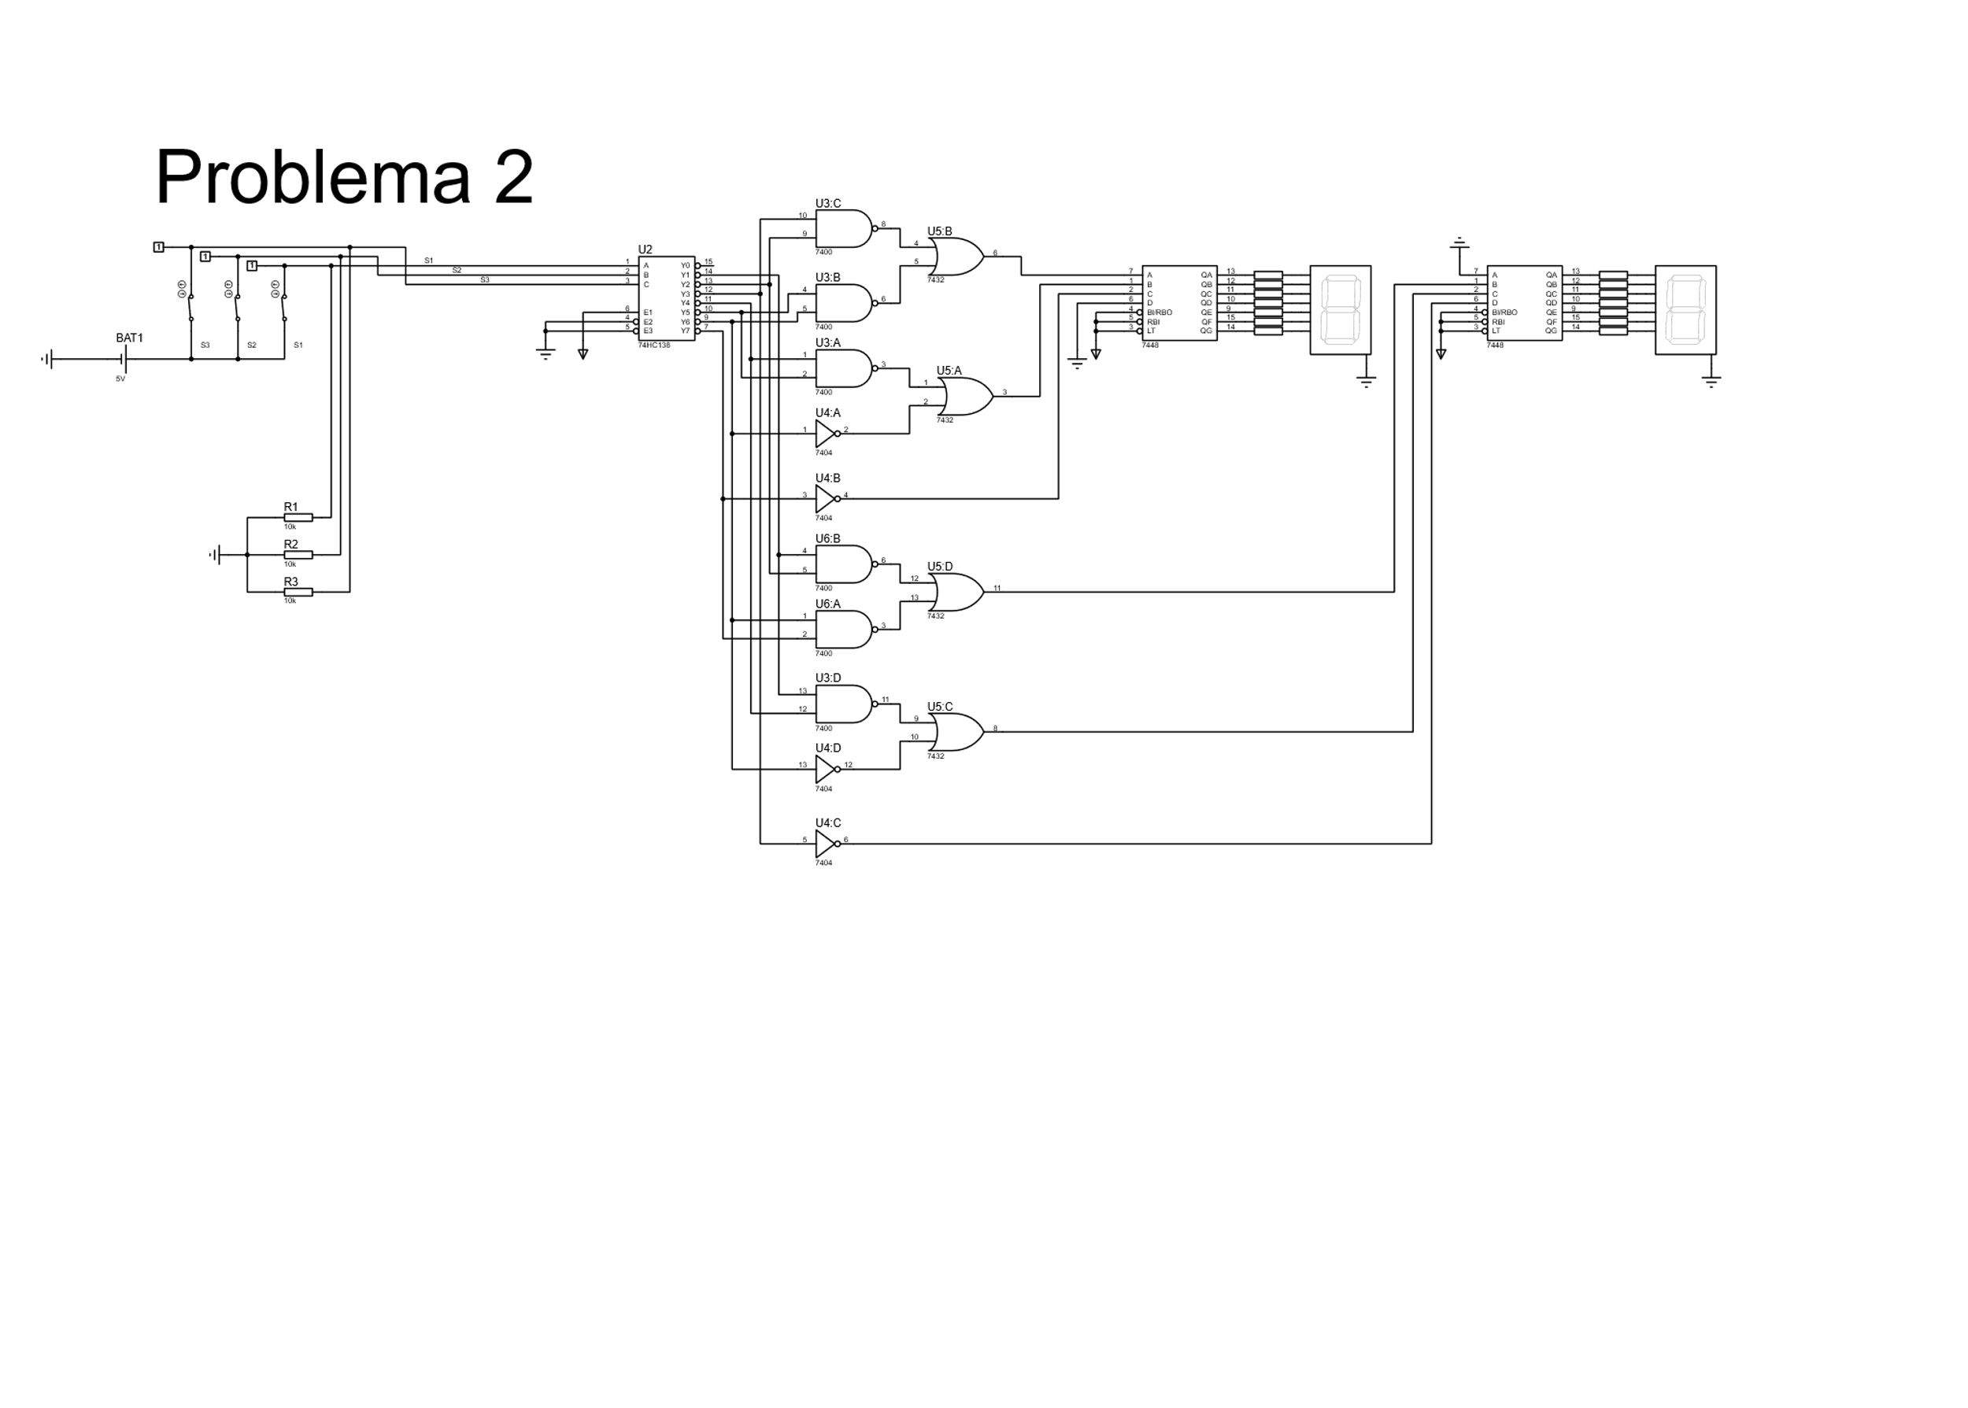

# PROBLEMA 3

## Black-Box

QC

S

QB

QA

Contador Ascendente cíclico de tres bits

## Diagrama de estados

## No. Y tipo de Flip-Flops

$2^{n}=No estados=8$

$n=3 por lo tanto necesitamos 3 Flip-Flops JK$

## Asignación de valores a los estados

|  |  |  |  |
| --- | --- | --- | --- |
| Estado | QA | QB | QC |
| S0 | 0 | 0 | 0 |
| S1 | 0 | 0 | 1 |
| S2 | 0 | 1 | 0 |
| S3 | 0 | 1 | 1 |
| S4 | 1 | 0 | 0 |
| S5 | 1 | 0 | 1 |
| S6 | 1 | 1 | 0 |
| S7 | 1 | 1 | 1 |

## Tabla de excitación

|  |  |  |  |  |  |  |  |  |  |  |  |  |  |  |
| --- | --- | --- | --- | --- | --- | --- | --- | --- | --- | --- | --- | --- | --- | --- |
|  | Estado presente | | | Estado siguiente | | | A | | B | | C | | | |
| J | **QA** | **QB** | **QC** | **QA+1** | **QB+1** | **QC+1** | **JA** | **KA** | **JB** | **KB** | | **JC** | **KC** |
| 0 | 0 | 0 | 0 | 0 | 0 | 1 | 0 | X | 0 | X | | 1 | X |
| 1 | 0 | 0 | 1 | 0 | 1 | 0 | 0 | X | 1 | X | | X | 1 |
| 2 | 0 | 1 | 0 | 0 | 1 | 1 | 0 | X | X | 0 | | 1 | X |
| 3 | 0 | 1 | 1 | 1 | 0 | 0 | 1 | X | X | 1 | | X | 1 |
| 4 | 1 | 0 | 0 | 1 | 0 | 1 | X | 0 | 0 | X | | 1 | X |
| 5 | 1 | 0 | 1 | 1 | 1 | 0 | X | 0 | 1 | X | | X | 1 |
| 6 | 1 | 1 | 0 | 1 | 1 | 1 | X | 0 | X | 0 | | 1 | X |
| 7 | 1 | 1 | 1 | 0 | 0 | 0 | X | 1 | X | 1 | | X | 1 |

## Articulación Algebraica

* JA = QC*QB

|  |  |  |  |  |
| --- | --- | --- | --- | --- |
| QC\QA QB | 00 | 01 | 11 | 10 |
| 0 | 0 | 0 | X | X |
| 1 | 0 | 1 | X | X |

* KA = QC*QB

|  |  |  |  |  |
| --- | --- | --- | --- | --- |
| QC\QA QB | 00 | 01 | 11 | 10 |
| 0 | X | X | 0 | X |
| 1 | X | X | 1 | 0 |

* JB = QC

|  |  |  |  |  |
| --- | --- | --- | --- | --- |
| QC\QA QB | 00 | 01 | 11 | 10 |
| 0 | 0 | X | X | 0 |
| 1 | 1 | X | X | 1 |

* KB = QC

|  |  |  |  |  |
| --- | --- | --- | --- | --- |
| QC\QA QB | 00 | 01 | 11 | 10 |
| 0 | X | 0 | 0 | X |
| 1 | X | 1 | 1 | X |

* JC = ¬QC

|  |  |  |  |  |
| --- | --- | --- | --- | --- |
| QC\QA QB | 00 | 01 | 11 | 10 |
| 0 | 1 | 1 | 1 | 1 |
| 1 | X | X | X | X |

* KC = QC

|  |  |  |  |  |
| --- | --- | --- | --- | --- |
| QC\QA QB | 00 | 01 | 11 | 10 |
| 0 | X | X | X | X |
| 1 | 1 | 1 | 1 | 1 |

## Diagrama Digital

